**Meet our fantastic Women in Engineering**

It was International [Women in Engineering Day](https://www.inwed.org.uk/) on 23 June. This year’s theme is ‘Together We Engineer’.

Women engineers are still hugely under-represented, with 2024 figures indicating that in the UK only 16% of engineers are women. As an organisation, HSE are proud to support the day and promote the role of our fantastic women engineers. It’s important that more young women and girls see their potential to take up engineering careers.

This year, we’re featuring 6 of our colleagues from across HSE who’ve shared their thoughts on the day.

**Rhiannon Thomas**

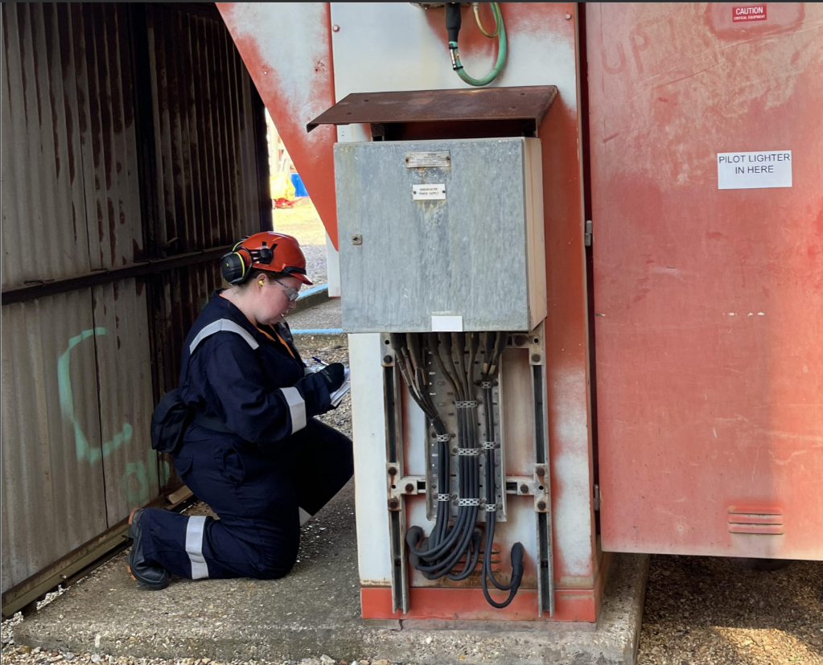

Rhiannon is a Chartered Chemical Engineer and works as a Principal Specialist Inspector in the Process Safety unit in Chemicals, Explosives and Microbiological Hazards Division, she has been in HSE 10 years. Before joining HSE Rhiannon worked in industry on a large Upper Tier COMAH (control of major accident hazards) chemical site for 10 years first as an engineer in design and operations and then as the site safety manager. Now as an Inspector Rhiannon mostly proactively inspects COMAH sites to try and prevent fires, explosions and toxic gas releases and investigates if a site has an incident involving their process.

Rhiannon says:

***“ In Process Safety we support all divisions across HSE, this is what keeps the job really interesting because I could be at a refinery in Southampton checking compliance with an Improvement Notice (see photo) one week and supporting a member of my team inspecting with Inspection Division following a concern from London Fire Brigade at a vegetable oil manufacturer who had had numerous fires from handling large volume of flammable hexane the next week.”***

To find out more about one of Rhiannon’s recent projects see ‘[Tata Steel Permit to Work Intervention](https://www.hse.gov.uk/research/assets/docs/annual-science-review.pdf#page22)  in this year’s Annual Science Review.

**Louise Atkin**



Louise works in HSE’s Energy Division and leads the Offshore Materials and Corrosion Team. She has a Degree in Corrosion Control Engineering and a Masters Engineering Materials. Louise is a Chartered Mechanical Engineer. She joined HSE in 2001 and has worked in Science Division’s Major Hazards, Engineering Materials and Field Engineering teams before transferring to Energy Division - Offshore in 2012.

Louise says:

***“I was always interested in problem solving from a young age, and when I became aware that there was a career in engineering failure investigation it was my ambition to follow that path. The natural progression from finding out why things fail to preventing that failure through research advice and education is an important part of my role and the role of my colleagues in HSE. I’m very proud of our successful collaboration across HSE divisions and technical disciplines to produce evidence based research to improve safety.”***

To find out more about one of Louise’s recent projects see ‘[When welding goes wrong: learning from past failures’](https://www.hse.gov.uk/research/assets/docs/annual-science-review.pdf#page8) in this year’s Annual Science Review.

**Rachel Cruise**

Rachel was promoted to the role of Principal Engineer in Structures last year and has a PhD. in Structural Engineering. She has previously worked in the construction industry and academia. Rachel has worked on a number of research projects to support the Building Safety Regulator in its role of raising the safety standards of all buildings, in particular to evidence the fire and structural safety of 3D or Volumetric Modular Construction, a Modern Method of Construction. In her new role she will also contribute to incident investigations to help understand structural safety issues.

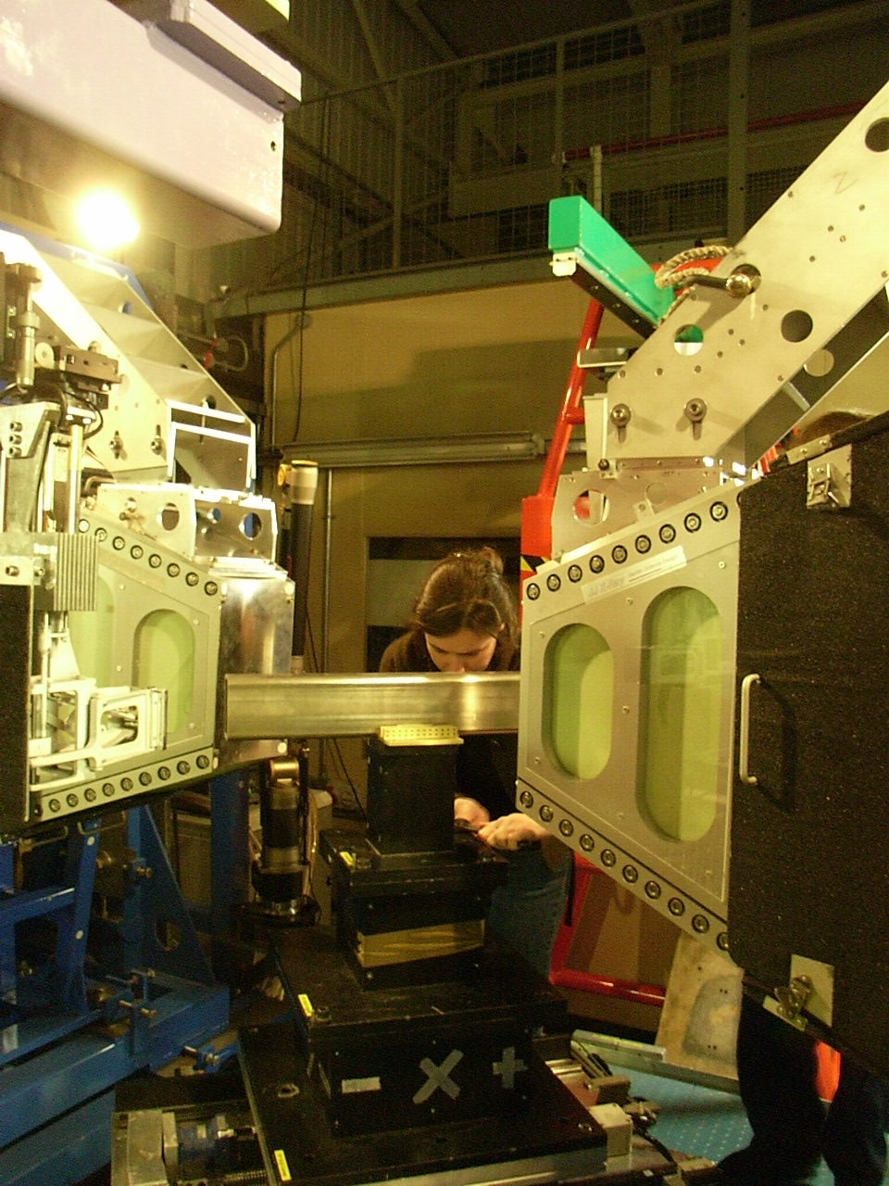

Rachel says:

***“I currently work closely with amongst others Material Engineers, Fire Safety Engineers and Risk Scientists. I have always enjoyed working across disciplinary boundaries inorder to have the opportunity to continue to learn. Designing and constructing a building is a multi-disciplinary activity and ensuring the safety of our built environment requires multi-disciplinary expertise.”***

To find out more about one of Rachel’s recent projects see ‘[The Building Safety of Volumetric Modular Construction](https://www.hse.gov.uk/research/assets/docs/annual-science-review.pdf#page13)  in this year’s Annual Science Review.

**Aneta Nemcova**

Aneta is a Senior Engineering Materials Scientist within the Major Hazards Group at Science Division. She has worked on a number of incident investigations while also supporting various research projects including work in net zero area. Aneta holds a PhD in Material Science and Engineering from Brno University of Technology in the Czech Republic. She is a Professional Member of the Institute of Materials, Minerals and Mining, and has been recently registered as a Chartered Engineer.

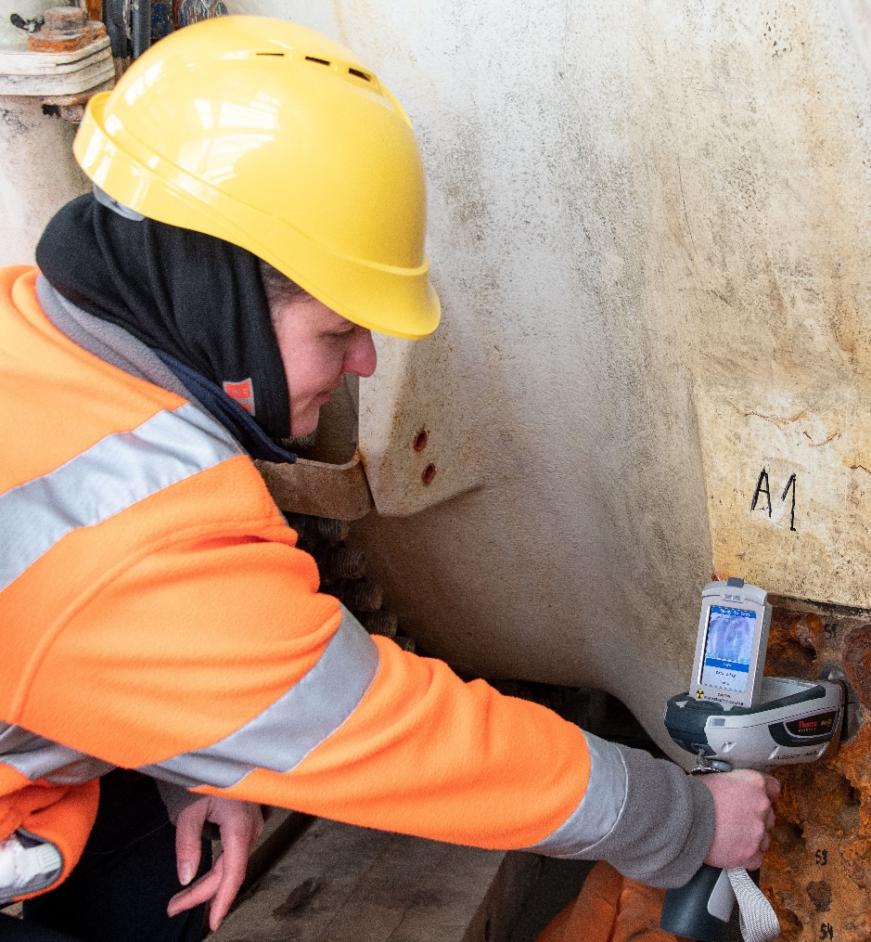

Aneta says:

***“It is rewarding to know that the work we do has a real and lasting impact. Working at HSE as a materials scientist gives me the chance to use my technical skills in meaningful ways. Even though, engineering has historically been a male-dominated field, through my career I have I received great support for my personal development and had opportunities to learn from many different disciplines.”***

To find out more about one of Aneta’s recent projects see [Investigation into a fatal incident involving a piling rig](https://www.hse.gov.uk/research/assets/docs/annual-science-review.pdf#page6) in this year’s Annual Science Review.

**Elizabeth Cain**

Liz joined HSE in October 2022 and works in the Mechanical Specialist team within the Specialist Division. She has a mechanical engineering degree and has been a Chartered Engineer since 2007, and a Fellow of the Institution of Mechanical Engineers since 2018.

Her team provides technical expertise to a wide range of activities in many different industries such as manufacturing, construction, agriculture, fairgrounds, to name but a few. They work closely with the Electrical Specialist team.

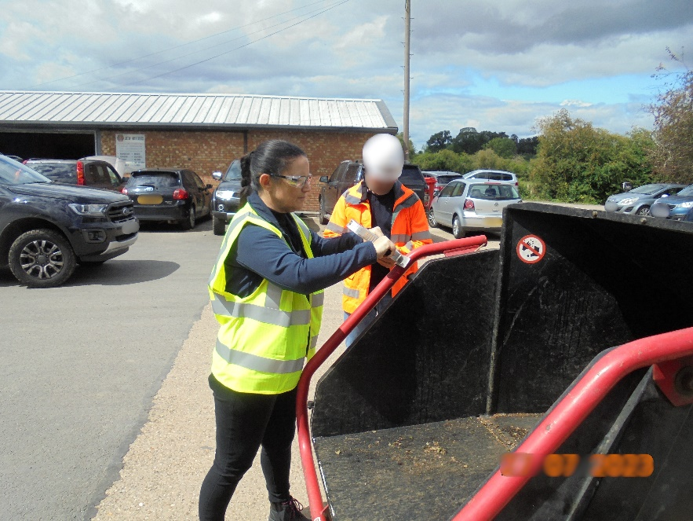

Liz says:

***“My background is in pressure systems and manufacturing of machinery but in this role you are never quite sure what you will be working on next – there is always something new to learn. I have worked on a number of investigations with various machinery such as ride on lawn mowers, fork lift trucks, horse exercisers, wood chippers, MEWPs, HGVs. It makes for a very interesting role.”***

**Clare Atherton**

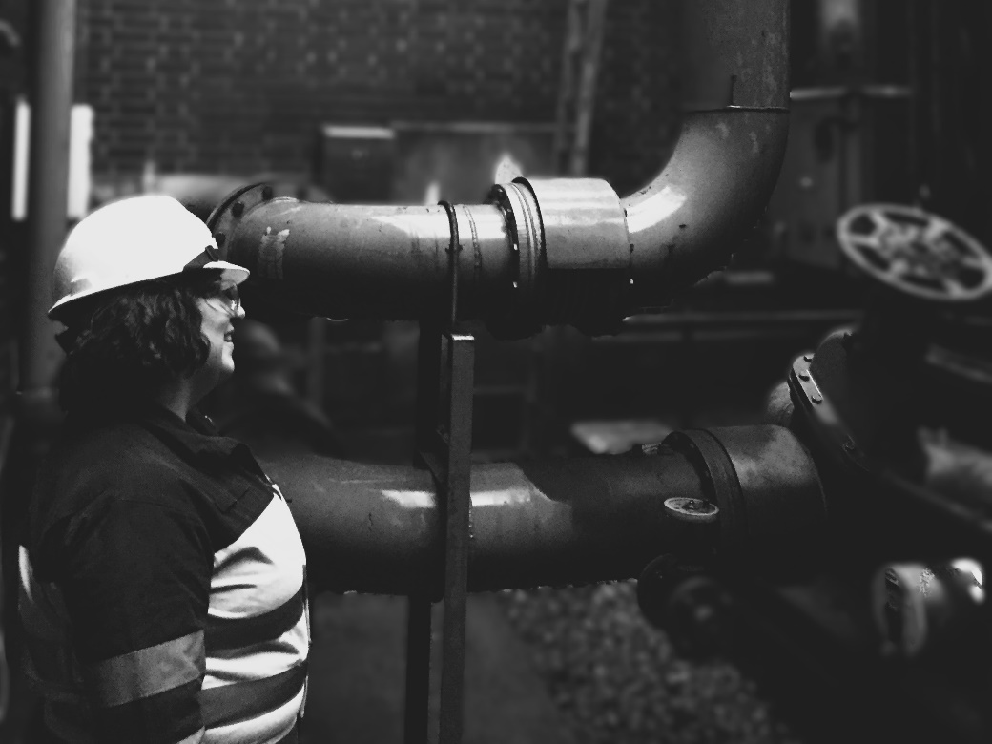

Clare initially joined the HSE in April 2020 as a Specialist Inspector in Field Operations, since 2024 her role has been as an Electrical & Control Systems Specialist in Specialist Division. Clare has a master’s degree in Engineering, has been an accredited Functional Safety Engineer since 2015 and a Chartered Engineer since 2021. Clare is part of a team of electrical and mechanical engineers who provide technical support on a wide range of equipment and machinery and across a variety of industries including manufacturing, utilities, construction, fairgrounds, and events.

Clare says:

***“I started my career in the 80s as an apprentice electrician building controls systems for food processing machinery. Now I have over 30 years industry experience from the chemical, manufacturing, and utilities industries in the UK and Europe.  I am involved in investigation and inspection activities. I have seen how our inspections help make the workplace safer, and our investigations can provide insight into why an incident happened leading to changes which help make things safer for everyone.  I really enjoy my work with the HSE, every day is different.”***

If you want to read more about the work of the women we’ve featured here please see our [Annual Science Review 2025](https://www.hse.gov.uk/research/assets/docs/annual-science-review.pdf),